**GENERATING SINUSOIDS**

**LAB # 06**



**CSE301L Signals & Systems Lab**

Submitted by: **Shah Raza**

Registration No: **18PWCSE1658**

Class Section: **B**

“On my honor, as a student of University of Engineering and Technology, I have neither given nor received unauthorized assistance on this academic work.”

Student Signature: ______________

Submitted to: **Engr. Durr-e-Nayab**

Sunday, July 5th, 2020

**Department of Computer Systems Engineering**

**University of Engineering and Technology, Peshawar**

**Lab Objectives:**

Objectives of this lab are as follows:

* Generating Sinusoids.
* Addition of Sinusoids with variation in parameters and their plots.
* Linear Phase Shift concept when dealing with the sum of Sinusoids.

**Task # 1:**

Generate the 1x10 row vector v whose i‐th component is cos (iπ/4).

**Problem Analysis:**

Use for loop to get 10 values of V and plot them by using plot function.

**Code:**

for i=1:10

V(i)=cos(i*(pi/4));

end;

i=1:10;

figure,plot(i,V,'--','linewidth',2);

grid;

xlabel(‘x-axis’);

ylabel(‘y-axis’);

**Output:**

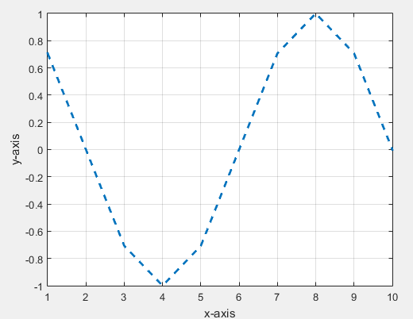

**Task # 2:**

Write matlab code that draws graphs of sin (nπx) on the interval ‐1≤x≤1 for n = 1, 2, 3, …, 8.

**Problem Analysis:**

Use for loop to get 8 values of V and plot them by using plot function.

**Code:**

x=0.5;

for n=1:8;

V(n)=sin(n*(pi*x));

end;

n=1:8;

figure,plot(n,V,'--','linewidth',3);

grid;

xlabel(‘x-axis’);

ylabel(‘y-axis’);

**Output:**

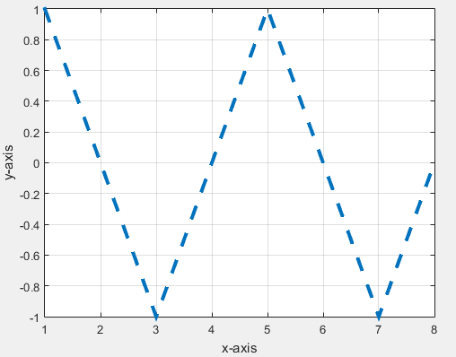

**Task # 3:**

Given the signal exp(‐x)sin(8x) for 0≤x≤2π, plot its continuous‐time and discrete‐time representations. Use subplot and label properly.

**Problem Analysis:**

Use for loop to obtain the signal and then plot its continuous and discrete time signals.

**Code:**

for x=1:2*pi;

V(x)=exp(-x)*sin(8*x);

end;

x=1:2*pi;

subplot(2,1,1);

stem(x,V);

title('Discrete-Time Signal');

subplot(2,1,2);

plot(x,V,'--');

title('Continuous-Time Signal');

**Output:**

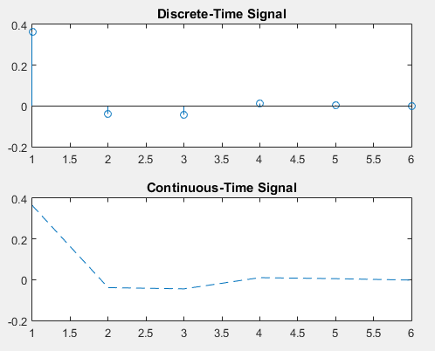

**Task # 4:**

Modify the given sine wave with phase shift of +pi/2. Then plot a cosine wave of the same frequency, amplitude, and phase shift of 0 in another subplot.

**Code:**

t=-3:1/1000:3;

A=2;

phase=pi/2;

f=1;

x1=A * sin(2*pi*f*t + phase);

subplot(2,1,1);

plot(t,x1, 'linewidth', 2);

title('Sine Signal');

xlabel('Time Index');

ylabel('Signal Amplitude');

phase=0;

x2=A * cos(2*pi*f*t + phase);

subplot(2,1,2);

plot(t,x2, 'linewidth', 2);

title('Cosine Signal');

xlabel('Time Index');

ylabel('Signal Amplitude');

**Output:**

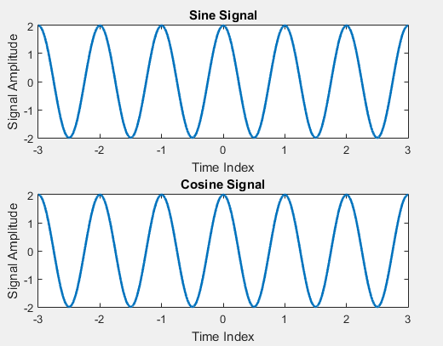

**Conclusion:**

Both the signals do not have any phase difference because sine and cosine are 90 degrees out of phase by default, so adding pi/2 to the phase angle of sine cancels out their phase difference.

**Task # 5:**

Write a program to generate a continuous‐time sine wave of frequency 3 Hz, positive phase shift of pi/2, and amplitude of 5. Also generate a continuous‐time cosine wave of frequency 3 Hz, amplitude of 5, and phase shift of 0.

**Code:**

t=-1:1/1000:1;

A=5;

phase=pi/2;

f=3;

x1=A * sin(2*pi*f*t + phase);

subplot(2,1,1);

plot(t,x1, 'linewidth', 2);

title('Sine Signal');

xlabel('Time Index');

ylabel('Signal Amplitude');

phase=0;

x2=A * cos(2*pi*f*t + phase);

subplot(2,1,2);

plot(t,x2, 'linewidth', 2);

title('Cosine Signal');

xlabel('Time Index');

ylabel('Signal Amplitude');

**Output:**

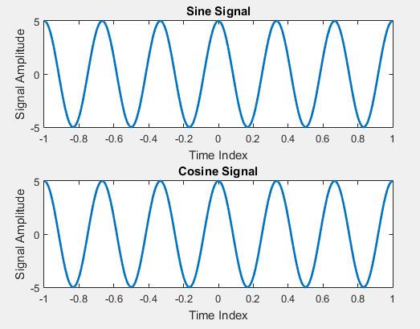

**Conclusion:**

Both the waves do not have any phase difference because sine and cosine are 90 degrees out of phase by default, so adding pi/2 to the phase angle of sine cancels out their phase difference.

**Task # 6:**

Write a general program that takes ‘n’ sinusoids from user of the same frequency, amplitude, and phase. Plot the individual sinusoids & the resultant using subplot function on the same figure.

**Problem Analysis:**

Ask the user to enter the number of Sinusoids required then use this number in a for loop to generate the Sinusoids with the given values. Add all the sinusoids to get a resultant sinusoid.

**Code:**

num=input('Enter the Number of Sinusoids: ' );

x1=0;

for n=1:num

f=0.5; Phase=0; A=1;

t=-2:0.01:2;

x=A*cos(2*pi*f*t + Phase);

subplot(num+1,1,n);

plot(t,x);

title('Sinsoidal Signal');

x1=x1+x;

grid;

end;

subplot(num+1,1,n+1);

plot(t,x1);

title('Resultant Sinsoidal Signal');

grid;

**Output:**

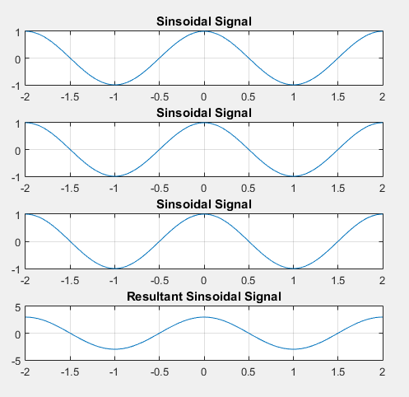

**Task # 7:**

Write a general program that takes ‘n’ sinusoids from user of the same frequency and phase with varying amplitudes. Take amplitude from the user on run time. Plot the individual sinusoids & the resultant using subplot function on same figure

**Problem Analysis:**

Ask the user to enter the number of Sinusoids required then use this number in a for loop to generate the Sinusoids. At each iteration ask the user to enter amplitude for each sinusoid. Add all the sinusoids to get a resultant sinusoid.

**Code:**

num=input('Enter the Number of Sinusoids: ' );

x1=0;

for n=1:num

f=0.5; Phase=0;

A=input('Enter amplitude: ');

t=-2:0.01:2;

x=A*cos(2*pi*f*t + Phase);

subplot(num+1,1,n);

plot(t,x);

title('Sinsoidal Signal');

x1=x1+x;

grid;

end;

subplot(num+1,1,n+1);

plot(t,x1);

title('Resultant Sinsoidal Signal');

grid;

**Output:**

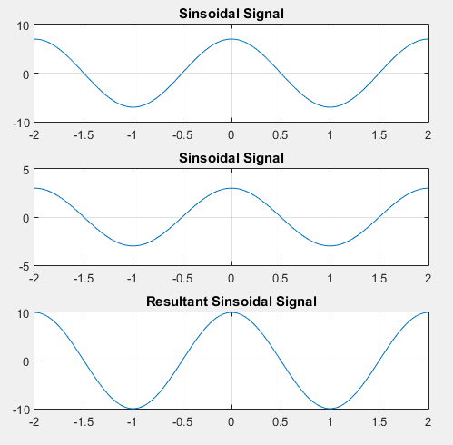

**Task # 8:**

Write a general program that takes ‘n’ sinusoids from user of same amplitude and phase with varying frequencies. Take each frequency from user on run time. Plot the individual sinusoids & the resultant using subplot function on same figure.

**Problem Analysis:**

Ask the user to enter the number of Sinusoids required then use this number in for loop to generate the Sinusoids. At each iteration ask the user to enter frequency for each sinusoid. Add all the sinusoids to get a resultant sinusoid.

**Code:**

num=input('Enter the Number of Sinusoids: ' );

x1=0;

for n=1:num

f=input('Enter frequency: ');

Phase=0; A=5;

t=-2:0.01:2;

x=A*cos(2*pi*f*t + Phase);

subplot(num+1,1,n);

plot(t,x);

title('Sinsoidal Signal');

x1=x1+x;

grid;

end;

subplot(num+1,1,n+1);

plot(t,x1);

title('Resultant Sinsoidal Signal');

grid;

**Output:**

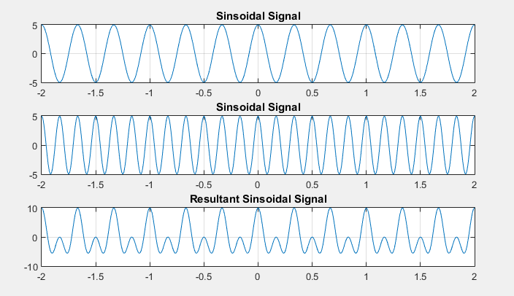

**Task # 9:**

Write a general program that takes ‘n’ sinusoids from user of same amplitude and frequency with varying phases. Take each phase from user on run time. Plot the individual sinusoids & the resultant using subplot function on same figure.

**Problem Analysis:**

Ask the user to enter the number of Sinusoids required then use this number in for loop to generate the Sinusoids. At each iteration ask the user to enter phase for each sinusoid. Add all the sinusoids to get a resultant sinusoid.

**Code:**

num=input('Enter the Number of Sinusoids: ' );

x1=0;

for n=1:num

f=0.5; A=5;

Phase=input('Enter Phases: ');

t=-2:0.01:2;

x=A*cos(2*pi*f*t + Phase);

subplot(num+1,1,n);

plot(t,x);

title('Sinsoidal Signal');

x1=x1+x;

grid;

end;

subplot(num+1,1,n+1);

plot(t,x1);

title('Resultant Sinsoidal Signal');

grid;

**Output:**

